Mafol's parents, like herself, were naturally born dwarfs, as opposed to the first of their kind, which were manifested by the Gods. This created a particular problem for the children born in the first decades, as parenting and childrearing were still new concepts.
Her younger years were mostly uneventful.

Friendship, love, carer pursuit, the usual.
Her first claim to fame was a discovery she made in the field of mechanics.
Though she still considers it as one of her greatest achievements, she was locally known more for her later work.
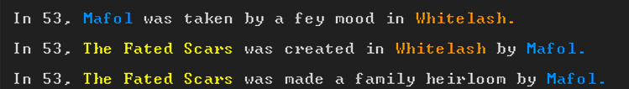
To the outside observer, it was little more than a toy hammer made out of raw yellowish metal. Only Mafol knew it's true power, and kept it by her side at all times.
Her life moved on peacefully after that.
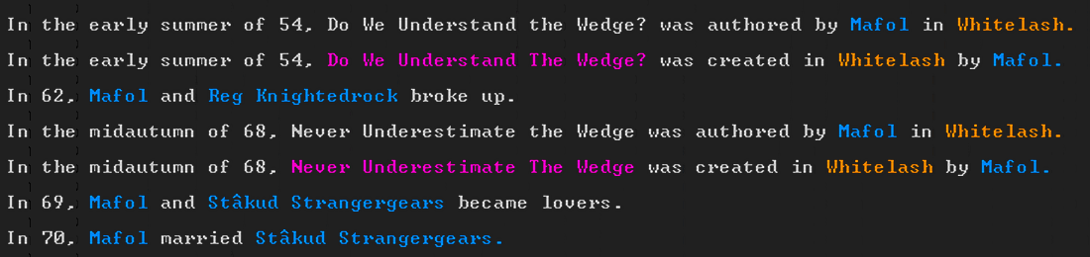
Though she always tried to making a lasting relationship, most of them did not stand the test of time. That is until she met Ducim.
Tired of fleeting loves, she vowed to make this one work, no matter what.
Consumed by her thirst for knowledge she pushed the envelope in the field of mechanics in Whitelash as the years went by. Over 45 years of hard work led to a breakthrough.
This single invention might have been the greatest discovery for all of dwarf kind in recorded history. Mafol, however, did not care for it. She felt nothing, burned out beyond comprehension. So, thirsting for excitement, she chose to chase a different life.
She used her renown from years of hard work to take over as the captain of the guard, just as her hero Goden was, as depicted on the Fated Scars:
She took on this position shortly after Goden decided to retire, and move out of Whitelash.
Unfortunately, the position she so willfully claimed turned out to not be what she expected.
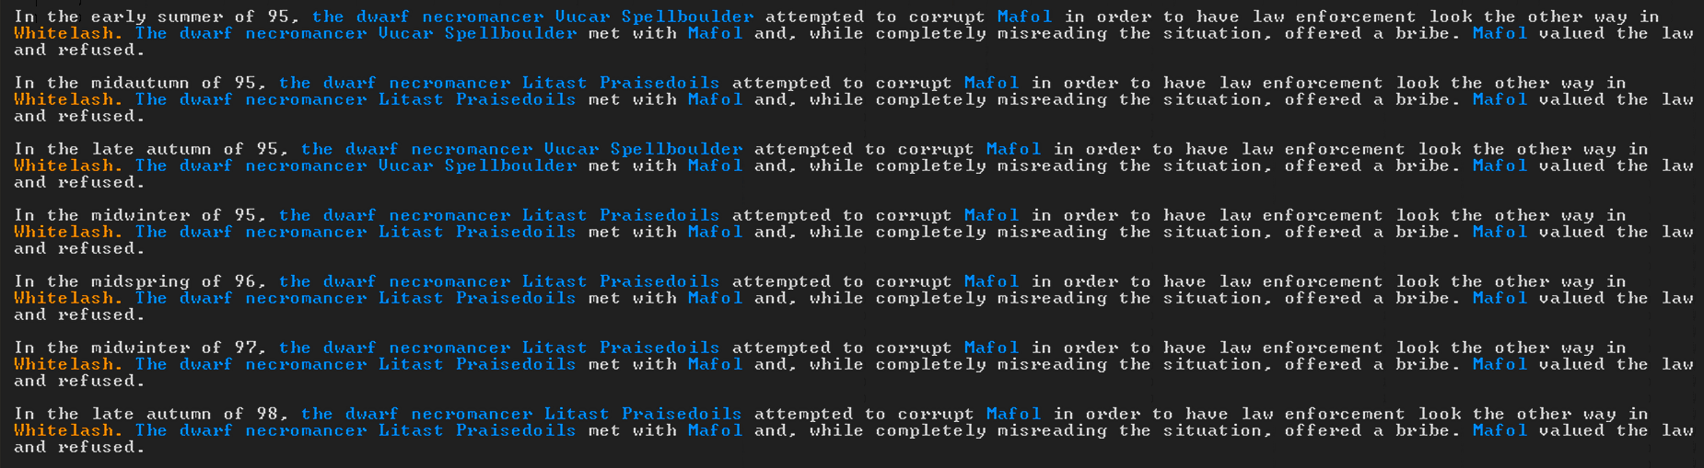
The prevalence of corruption shocked her to the core. Her refusal to take bribes and look the other way caused problems to many influential dwarfs. After 3 years sticking to her ethics and following the law, death threats started pilling up.
After almost 5 years of constant stress and struggle she finally snapped. And when Vucar Spellboulder started dangling eternal life in front of her, she realized that the only who can stop an evil immortal schemer, is a good immortal schemer. She sacrificed her morals and took the bait. However, he did not follow up on the deal, which sent Mafol on a path of vengeance.
She was consumed by the search for immortality, and accidentally infected her husband with it. Together they searched for a teacher, but it was Ducim who managed to unlock immortality first. Shortly after he tracked down Mafol who became his apprentice. This was the beginning of a very unusual period in their lives. As they were figuring out who they want to be and what they want to do with their new found immortality, they had a lot of adventures.

